CuentaColombia

A thematic curriculum unit about Colombia
based on oral tradition tales and folklore
[For a free download of the complete unit, visit www.miscositas.com]
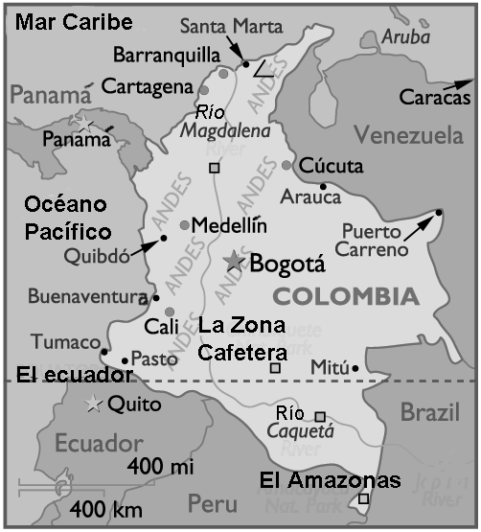
Lori Langer de Ramirez, Ed.D.
Chair, ESL and World Language Department
Herricks Public Schools, NY
Email: lori@miscositas.com
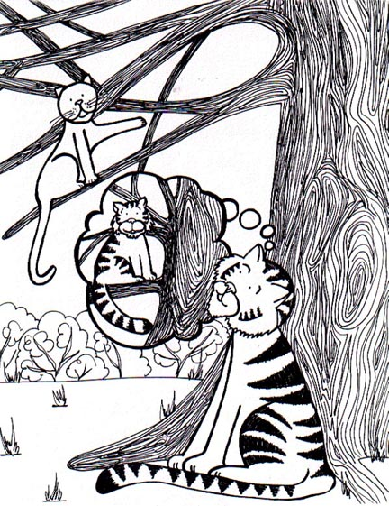
web: www.miscositas.com

Lección 1

Vamos al Amazonas

Language:

vocabulary
el Amazonas
el tigre
la pata
la nariz

phrases and structures
adjectives: ñato/a parado/a aplastado/a

verbos: lastimarse subir bajar aterrizar
señalar

Materials: - Colombia map (Appendix A)
- plane ticket (Appendix B)
- floor map of Colombia
- magic box
- Como el tigre… drawings colored-in and cut into small cards (see Appendix C)
- Activity Sheet #1 (animal/adjectives)

Activity: 1. Tell the class that the plane for Amazonas is leaving.
Give each student a plane ticket (see Appendix B) and
have them look at their maps (Appendix A) to locate the Amazon of Colombia as you point on the floor map.

- Tell students that they are traveling to the Amazon
to meet with a storyteller from that region. In order to
prepare for the story, the storyteller has sent a “caja
mágica” with items from her story.

- The teacher asks for volunteers to pull the various cards
(using cards from Appendix C) from the magic box. As each card is pulled from the box, the teacher asks the following questions:

a. ¿Quién tiene (i.e.:) el tigre?
- ¿Juanito tiene el tigre?
- ¿Juanito tiene el tigre o el gato?
- ¿Qué tiene Juanito?

- The teacher continues to practice the vocabulary words
by using these commands throughout the lesson:

a. Señalen el tigre.
b. Pon el tigre en tu cabeza.
c. Da el tigre a Mary.

5. Homework: Activity Sheet #1: Have students
connect the animal with the correct adjective.

Lección 2:

Cuento: Porque el tigre es ñato

Language:

vocabulary
el Amazonas el tigre la pata la nariz
la zona amazónica

phrases and structures
adjectives: ñato/a parado/a aplastado/a

verbos: lastimarse subir bajar aterrizar
señalar

adverbs: aquí antes después primero segundo
tercero

Materials: - Activity Sheet #1 (animal/adjectives)
- Activity Sheet #2 (cause and effect chart)
- Appendix D (master sheet for “Porque el tigre es ñato”)

Activity: 1. The students should go over their homework activity in small groups. You might explain to students that in the Spanish-speaking world (and in Colombia, especially), these adjectives are often used as nicknames (apodos) with people. They are almost always meant and taken in a friendly or affectionate way, and not in any way to offend people.

2. Separate the students into 3-4 small groups. Give each
group a copy of the the illustration from the story (use illustration from Appendix D).

3. Have the students predict what the story is about by
identifying what they see in the illustration.

- The students should write a brief story about the
illustration (e.g., including what happened before the
scene [antes] and what will happen afterwards
[después]).

- Each group then reports back to the class their version of
the story by reading their group version.

- Tell the students that the story they are about to hear
comes from la zona amazónica. Using Appendix D, read
the story to the students (you might also consider making
an audiotape of yourself or a native speaker reading the story).

NOTE: The text and full-color illustrations for the
“Porque el tigre es ñato” story are available on the Internet at the following web address: http://www.miscositas.com/tigre.html
You may want to have students visit the site to read the story after listening to the story in class.

- Homework: Activity Sheet #2: Ask the students to give
Fill in the cause and effect chart with events from the
story.

Lección 4:

Nosotros, los cuentistas

Language:

vocabulary
el Amazonas el tigre la pata la nariz
la zona amazónica el cuento el/la cuentista

phrases and structures
adjectives: ñato/a parado/a aplastado/a

verbos: lastimarse subir bajar aterrizar
señalar

adverbs: aquí antes después primero segundo
tercero

Materials: - Activity Sheet #2 (cause and effect chart)

Activity: 1. The students go over their homework activity (Activity Sheet #2) in pairs.

2. Before the students “leave” Colombia, they must leave behind a story. Have students write and illustrate an original story. They might present their story in one of the following ways:

- PowerPoint - videotape - a picturebook
- a website - audiotape - a skit/play

- Set aside a class period for the presentations of the
stories. Students should sit in a circle and present their
tales one by one to the class as a culminating activity.

Appendix A – Colombia map

(map adapted from www.graphicmaps.com)
Appendix B – tickets

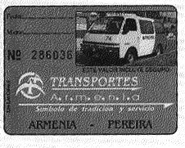

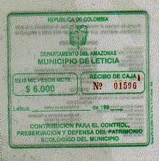
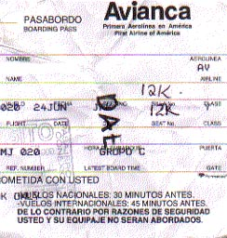

Appendix C – Porque el tigre es ñato … vocabulary cards

Copy onto card stock and cut out each individual card.

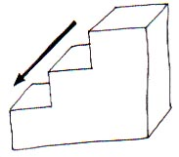 | 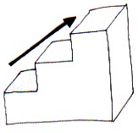
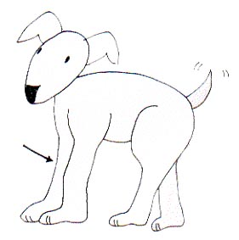 | 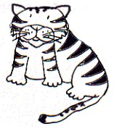
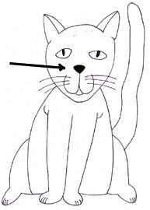 | 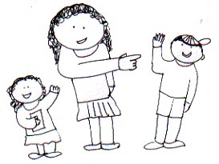
Appendix D – Porque el tigre es ñato … story and illustration

Tío Tigre y Tío Gato son primos. A los dos les encanta subir a los árboles, pero solamente Tío Gato sabe bajar sin lastimarse. El Tío Tigre siempre se queda atrapado. Un día Tío Tigre le dice a Tío Gato:

-- “Tío Gato, enseñame a bajarme de los árboles como lo haces tú.”

-- "Claro que sí," le respondió el Tío Gato. “Vámos.”

Entonces los dos animales subieron un árbol muy alto sin problema. En el tope, Tío Gato dijo:

-- "Ahora, date vuelta, baja la cabeza y sígueme.”

Tío Gato bajó primero. Dio vuelta, bajó la cabeza, saltó del árbol y aterrizó parado en las cuatro patas. Entonces le gritó a Tío Tigre que hiceiera lo mismo.

El Tío Tigre dio vuelta, bajó la cabeza, saltó del árbol y aterrizó en la cara, aplastando su nariz.

-- "¡Oye!" gritó el Tío Tigre, sobándose la nariz herida. “Hice lo que me dijiste y mira lo que me pasó.”

Enojado, el Tío Tigre persiguió al Tío Gato por todo el bosque. Con miedo, el Tío Gato se fue a vivir en la casa del hombre y ya no vive en el bosque. El Tío Tigre vive en el bosque, quedó ñato y todavía no sabe bajarse de los árboles.

Nombre: Fecha:

Actividad #1

Conecta cada animal a un adjectivo.

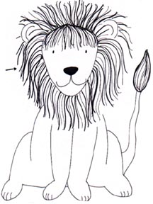
narizón

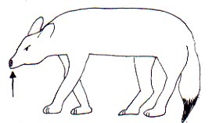
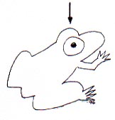
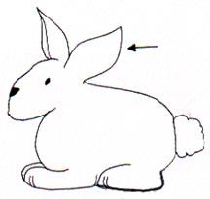
ojón
cabezón
Nombre: Fecha:

Actividad #2

Llena la gráfica de “causa y efecto” con información del cuento.

Primero pasó esto…

…que causó esto a pasar…

…que causó esto

a pasar…

…y al fin, el efecto fue esto.

